**MYP Personal Project (2018-2019)**

**How can I use the C++ programming language to create a smart mirror?**

**Abdul Khurram (Grade 11 Wadi)**

**Emirates International School Jumeirah**

**3790 Words**

***MYP Personal Project Report***

**Table of Contents**

**Investigating……………………………………………………………………................................ 3**

**The Goal……………………………………………………………………………………………………………………... 1.3-4**

**The Global Context......................................................................................................... 4**

**Research........................................................................................................................ 4-5**

**Planning........................................................................................................... 6**

**Student Designed Criteria.............................................................................................. 6-7**

**Action Plan.................................................................................................................... 8-9**

**Work Done Per Week.................................................................................................... 9**

**Visual Timeline.............................................................................................................. 10**

**Choosing a User Interface.............................................................................................. 10**

**Taking Action.................................................................................................. 11**

**Modifications to the Plan............................................................................................... 11**

**Effects of Research Plan and Process on Final Product.................................................. 11-12**

**Reflecting........................................................................................................ 13**

**Evaluation against Criteria........................................................................................... 13-14**

**New Insights on the Topic and the GC.......................................................................... 14**

**Development of the IB Learner Profile......................................................................... 15**

**Bibliography............................................................................................... 16-17**

**Appendix (Appendices A-J)......................................................................... 18-29**

**Investigating**

**The Goal**

*Goal: “The goal of this project is to create an interactive smart mirror, based on the C++ programming language.”*

Ever since the inception of the original iPhone back in 2007, I have been unremittingly fascinated with how something so small can do so much (even though I was only about 4 years old at the time). The iPhone redefined a whole new category of personal computing and constituted a completely new industry that would reinvigorate almost every aspect of our lives. But that was in 2007, almost 12 years ago, and this is now. Handheld computing has come a long way since 2007 and it has grown exceedingly beyond the constraints of just the iPhone by now. Today you can wear a computer on your wrist that is as powerful as a computer that would take up an entire room, just 20-30 years ago and if you own smartphone that was released after 2016, then that means you have more raw computational in your pocket than the NASA scientists had from all their super-computers, during the Apollo missions.

In 2009, an interconnected network of smart devices was proposed, it became known as the ‘Internet of Things’ or ‘IoT’ for short. The main selling point of IoT was the speedy analysis and transfer of information known as ‘Big Data’ from device to device. The Google definition of big data is, *“Extremely large data sets that may be analyzed computationally to reveal patterns, trends, and associations, especially relating to human behavior and interactions.”* Back in 2009 this was nothing more than a concept, a cool thought experiment, but now with new technologies like cloud computing and the general exponential increase in computing power since then, IoT technology is now a reality something so widespread that you probably use some form of it every day, maybe without even realizing it. One practical, real-life application of this is if you were googling for “cheapest iPhone 8 Plus phone cases” on your phone, the search term ‘phone cases’ is extrapolated in conjunction with the model number/identifier of the phone (iPhone 8 Plus) and the term ‘cheap’ by an algorithm especially designed for this type of data analysis, to show you a Souq.com ad for 4 different iPhone 8 Plus cases, all under 50 AED. This ad will be visible on all of your devices signed into the same Google account, this is known as ‘targeted advertising’. A more user-orientated application is with smart homes, you ask the personal assistant on your phone to unlock the door, turn the lights on and set the temperature to 20 degrees as soon as your son reaches home. As soon as your son is in range of the home’s security system, it will unlock the door just for him, turn the lights on and adjust the thermostat all simultaneously and extremely efficiently.

All of this is part of an extremely lucrative market that spells out one thing. Above all else, people want convenience. They want their data presented to them in a way that is both unobtrusive and intuitive, while still feeling like something straight out of Star Trek. That’s why my goal for the personal project is to create an interactive smart mirror, based on the C++ programming language. Not only is a project like this extremely challenging, but it is also something I am genuinely interested in. One programming language I am already quite adept with is the ‘Swift’ programming language, which is quite similar to C++ is a number of ways, but is generally more complex, since it is much older and has much wider range of practical applications/platforms. This project will require me to have at least an adequate understanding of the C++ programming language for it to be successful. Unfortunately for me, C++ isn’t the only thing I will have to learn. I will also have to figure out a way to incorporate all the technical aspects of this project in an easy-to-use, intuitive and inviting package. This project is especially personal to me, not only because it is part of my particular area of interest, but because it requires me to learn new skills that I am not extremely familiar with yet, but will enjoy learning regardless.

**The Global Context**

Out of the six available options to choose from, I could have chosen any one of them and created some sort of link to it, with enough effort. However one specific Global Context seemed to fit this project particularly well, “Scientific and Technical Innovation”. This is especially relevant to my project goal, because my plan is to take a fairly technical and out-of-reach aspect (for most people) of a really cool piece of technology and innovate it to the point where it is intuitive, easy-to-use and not nearly as intimidating as it would have been otherwise.

**Research**

Aside from the research on handheld computing IoT devices I already covered in ‘The Goal’ section, I needed to carry out some more specific preliminary research about the mirror itself and the parts/resources that I would need to successfully create a polished and refined final product, as well as brushing up on some C++.

First and foremost, I needed to find some kind of online guide to just point me in the right direction and just outline the basics of what needed to be done. A few google searches later I came across an article on the tech journalism website known as ‘The Verge’ (<https://www.theverge.com/>). To be brutally honest, the guide wasn’t very well written and a complete beginner would probably more lost than when they first started. Fortunately for me, I did have some prior knowledge about the topic, so I had a basic understanding of what I was going to do for mine.

The next step was to focus on the software side of things. Although I had originally intended to write all the underlying code myself, I later found that it would be much less time-consuming and much less risky to use an open-source GitHub project as the basis of my user-interface and then just make whatever edits I deemed necessary, with my knowledge of the C++ programming language. ‘GitHub.com’ is an online community where people can share their open-source projects for other people to use and edit, the project I settled on was the ‘MagicMirror’ because of its simplicity and flexibility in terms of what you can edit.

All this new information, in combination with my prior knowledge in the subject ‘Design’ (AKA IT) gave me a general idea of what I was going to do and how I was going to do it.

**Planning**

**Goal:**

*The goal of this project is to create an interactive smart mirror, based on the C++ programming language.*

**Student Designed Criteria**

|  |  |  |  |  |
| --- | --- | --- | --- | --- |
|  | **Aesthetics** | **Function** | **User Friendliness** | **Costs** |
| **7-8** | The product looks like an ordinary mirror when it is powered off. When it is powered on there is no backlight ‘bleed’ and all UI elements are clear. | The mirror displays any and all useful information the user may want, like time, weather, a news feed and more. It is fully customizable/modular and does not clutter the view in any way. | The product can be used and customized by anyone from any age group with little to no effort. The language of the user interface can also be changed. | The product only costs around 600 AED to build, inclusive of shipping charges and does not compromise any quality for the lower price. |
| **5-6** | The product almost looks like an ordinary mirror when it is powered off. When it is powered on there is very little backlight ‘bleed’ and all UI elements are fairly clear to the point where they are legible. | The mirror displays many widgets with useful information the user may want, like time, weather, a news feed and more. It is customizable/modular to an extent and does not clutter the view that much. | The product can be used and customized by most people aged 12-50 with some effort. The language of the user interface can also be changed. | The product costs around 800 AED to build, inclusive of shipping charges and does not compromise any quality for the lower price. |
| **3-4** | The product resembles an ordinary mirror when it is powered off. When it is powered on there is some backlight ‘bleed’ and the UI elements are somewhat legible. | The mirror displays some widgets with useful information the user may want, like time, weather, a news feed and more. It is barely customizable/modular and can sometimes clutter the view. | The product can be used and customized by some people aged 18-50 with an adequate amount of effort. The language of the user interface cannot be changed. | The product costs around 1000 AED to build, inclusive of shipping charges. The price is somewhat justifiable by the overall quality of the product. |
| **1-2** | The product does not look like a mirror, when it is powered on it is not possible to read or see any of the UI elements. | The mirror displays no widgets with useful information the user may want, like time, weather, a news feed and more. It is not customizable/modular and almost always clutters the view. | The product is barely usable and cannot be customized in any way. The language of the user interface cannot be changed. | The product costs more than 1000 AED to build, inclusive of shipping charges. The high price is not reflected at all by the overall quality of the product. |

Criteria of Success is available in appendix *(Appendix J)*.

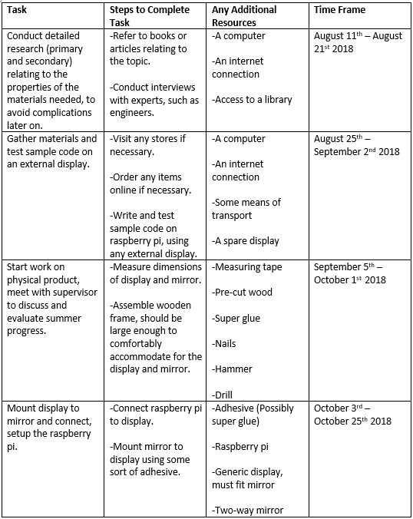**Action Plan**

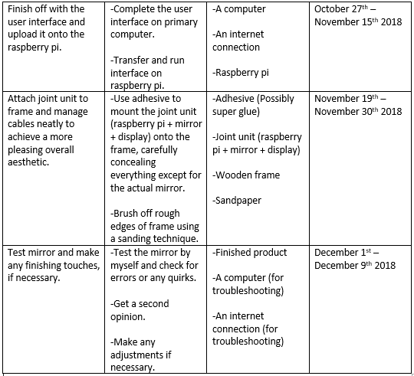

**Work Done Per Week**

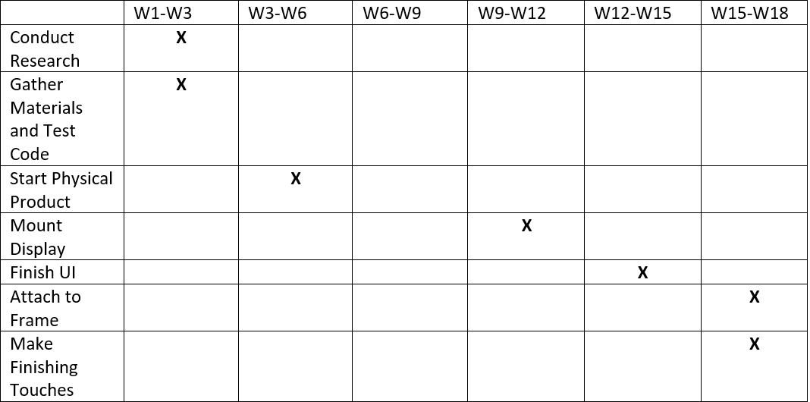

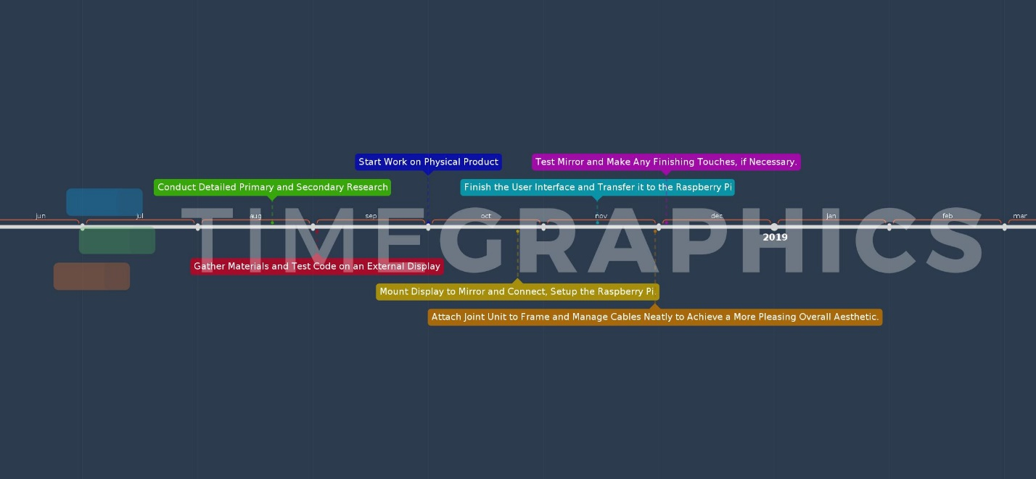**Visual Timeline**

**Choosing a User Interface**

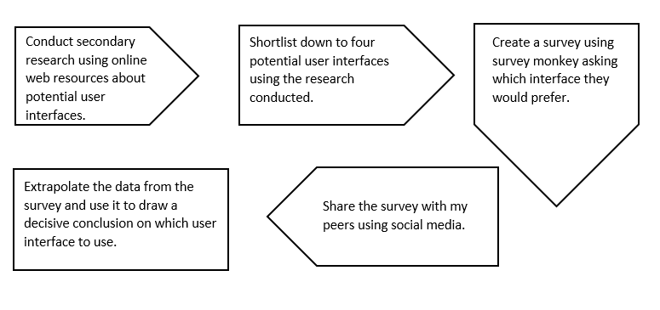

**Taking Action**

**Modifications to the Plan**

As soon as I did a little bit more research on some of the more technical aspects of building my smart mirror, I came to the realization that I had just simply allocated too much time towards building the physical product and too little time into finding the most cost-effective parts, along with fine-tuning the software. This led me to re-evaluate my action plan, to a certain extent, in favor of slightly delaying the ‘Start work on physical product’ section to about a month after it was intended to begin. In the extra time that I had cleared up, I decided that it would be a good time to start evaluating different user-interface devices *(Appendix A)*. I had narrowed the list down to three remaining candidates and eventually decided on just going for the keyboard and mouse option *(Appendix B)*.

One other change I made, which I’ve already briefly mentioned in the ‘Investigating’ section of this report, had to do with the software side of things. This decision involved ditching my original plan of building a user-interface from scratch and instead opting to use, and slightly modifying, an existing open-source user-interface known as ‘MagicMirror’. The final, slightly reworked user-interface can be found in the appendix *(Appendix C).*

One other change I made had to do with something that I hadn’t initially thought-out so well, just because it seemed so simple and menial, but something that actually turned out to be a bit of a challenge. The change in question was the actual mount for the raspberry pi. I eventually settled on 3D printing the mount I needed for my specific model of raspberry pi (Raspberry Pi 3 Model B). There were several CAD files available online, ready to print, I chose the one with the most downloads. The link to the download page for the 3D model is available in the bibliography, while the images of the model before and after printing are available in the appendix *(Appendix D)*.

**Effects of Research Plan and Process on Final Product**

Although I had initially thought that creating a research plan was going to be a waste of valuable time and effort, it turned out to be quite effective at helping me create a final product that adhered to the many constraints set by my criteria of success and my student-designed criteria. The research, in conjunction with some of my prior knowledge, armed me with enough general knowledge and know-how to overcome any and all challenges in my path by creating an alternative method for anything that didn’t work. This extra skill-set that I had developed, all thanks to the research I had conducted, was especially helpful in such a technical, time-constrained project such as this one.

One of the best examples of one of these extra skills coming in handy was when I ran into a plethora of errors during the compiling of the software, but still managed to pull-through thanks to my new-found knowledge of the C++ programming language and the specialized Linux distribution known as ‘Raspbian’ *(Appendix E)*. An example of my prior knowledge coming in handy is when I had to design an all-new mounting technique, as I mentioned earlier, that issue was solved by 3D printing a custom mount for my specific model of raspberry pi *(Appendix D)*.

**Reflecting**

**Evaluation against Criteria**

The rubric I had designed earlier, in the planning section of the report, specified four main criteria. Like any conventional rubric, each criteria had a certain set of requirements that had to be met, in order to determine which level would be awarded (levels 1-8). The first criteria was ‘Aesthetics’. This criteria required three main specifications to be fulfilled in order to score a level 7-8, those three specifications include:

* **The product must look like an ordinary mirror when powered off.**
* The product must have no backlight ‘bleed’.
* **All UI elements must be clear and well-spaced.**

After a meticulous evaluation of each of those specifications with my product, I came to the conclusion that only two of those specifications described my product well. Although the backlight bleed wasn’t too bad, it was still prominent enough to be considered noticeable. However this is definitely not because of lack of trying, I devoted a significant chunk of my personal project time trying to calibrate and fine-tune the display’s contrast, brightness and even color saturation settings with no avail. It does look a lot better than it did without any of the additional calibration and fine-tuning, however it is still not good enough to warrant a 7-8 for this specific criteria. That’s why I gave myself an overall grade of 7 for this criteria.

The second criterion I had to fulfill was the ‘Function’ criteria. This criteria also consisted of three main specifications that had to be fulfilled. Those three specifications include (Level 5-6):

* **The mirror displays many widgets with useful information the user may want, like time, weather, a news feed and more.**
* It is customizable/modular to an extent.
* **It does not clutter the view that much.**

I awarded myself a level 5 for this criteria. The reason I didn’t get a level 6 was because the user-interface was not customizable to an extent that I would have liked, at least not with the current software. I didn’t score a level 7-8 because there wasn’t as much of a varied selection widgets as I would have liked and some of the modular widgets could scale incorrectly at times causing minimal, but barely noticeable clutter.

The next criterion was the ‘User Friendliness’ criteria. This criteria consisted of just two main specifications (Level 5-6):

* **The product can be used and customized by most people aged 12-50 with some effort.**
* **The language of the user interface can also be changed.**

I awarded myself a level 6 for this criteria. The reason I didn’t score any higher was because most people were able to figure out how to customize it (when I let a few of my family and friends try using it), but it still took them a substantial amount of time to figure it out and all of the people tested had some basic knowledge of how to use computers, so it wasn’t really an accurate representation of the entire target demographic. The language could also be adjusted, but that too required some basic prior knowledge and a significant portion of time.

The last criterion was the ‘Costs’ criteria. This criteria also only consisted of just two specifications (Level 7-8):

* **The product only costs around 600 AED to build, inclusive of shipping charges.**
* **The product does not compromise any quality for the lower price.**

I awarded myself the maximum mark for this criteria (level 8) because it only cost about 50 AED extra to build, inclusive of all shipping and tax charges, coming in at an impressive net total of just 652 AED. Despite the lower price, the product retained its professional aesthetic and used only high-quality, cost-effective parts, sourced from reliable and well-known retailers.

Marked rubric is available in appendix *(Appendix F).*

**New Insights on the Topic and the GC**

Albert Einstein once famously said, *“Failure is success in progress”*. Until now, I never fully understood what that quote actually really meant. I personally feel that the planning and creating phase of this project gave me a much more valuable insight on topics like IoT and how they may be developed in the near future. One such valuable insight was just the sheer complexity behind something as simple as getting the weather for your location. It really gives you some perspective on how difficult it can be to take something that already exists and put it into a much simpler form-factor, which may seem slightly counter-intuitive to some people. That’s not to say that the research didn’t offer any valuable insight or knowledge. I wouldn’t have even known about any of these topics if I hadn’t conducted the research and let’s not forget that learning C++ also required a fair bit of research, even if it wasn’t directly from the internet.

The process also offered some insight about the Global Context, “Scientific and Technical Innovation”. The project as a whole taught me that the quote, *“Necessity is the mother of invention”*, couldn’t be any truer. People don’t know what they want until they have it. Henry Ford once said, *“If you asked people what they want, they would say faster horses”*, this quote refers to how people didn’t think the automobile was necessary because their horses worked just fine. Similarly, about 80% of all people I interviewed said they would buy a smart mirror after they had tried, compared to about only 40% who were asked before (the same people were asked before and after). The results of that specific survey can be seen in the appendix *(Appendix G)*.

**Development of the IB Learner Profile**

To be brutally honest, I think I developed a little bit of every IB Learner Profile trait. However, that isn’t exactly specific. The two IB Learner Profile traits I think I developed the most would have to be the trait of being a risk-taker, while also being reflective at various points throughout the development process of my product. The reason I say that I was a risk-taker is because of the nature of my product. Not only was I risk-taker at the beginning of my personal project when I chose such a technical product, but also throughout the project when I tried new methods of completing certain tasks. Most of these methods were simply based of my own intuition and had little to no anecdotal evidence to support them, although they did end up working out quite well a lot of the time. One example is when I opted to use a TV mount to mount my mirror to the wall, the monitor stand is more commonly used but is not nearly as aesthetically pleasing *(Appendix H)*.

I was also reflective at several points throughout the development of my product, however the best example I can think of was towards the end of the development cycle. As I mentioned earlier, it took a lot of valuable time and effort to calibrate the monitor to the point where there was as little backlight bleed as possible. Had I not reflected on the aesthetic appeal of my product at that point in the development cycle, then I never would have even gotten the 7 that I awarded myself for the ‘Aesthetics’ criterion, in the ‘Evaluation against Criteria’ section of my report. The image of my final product is available in the appendix *(Appendix I)*.

Both the IB Learner Profile traits that I have mentioned above, among some of the others that I didn’t mention, are absolutely quintessential examples of how this personal project, as a whole, has helped me develop and progress as a person.

**Bibliography**

* MichMich. 2016. MagicMirror. [ONLINE] Available at: https://github.com/MichMich/MagicMirror. [Accessed 16 June 2018].
* Mihir Patkhar. 2016. 6 Best Raspberry Pi Smart Mirror Projects We've Seen So Far. [ONLINE] Available at: https://www.makeuseof.com/tag/6-best-raspberry-pi-smart-mirror-projects-weve-seen-far/. [Accessed 7 June 2018].
* Chaim Gartenberg. 2018. Building your own smart mirror is surprisingly easy. [ONLINE] Available at: https://www.theverge.com/circuitbreaker/2017/8/17/16158104/smart-mirror-diy-raspberry-pi-commute-weather-time-gadget. [Accessed 18 August 2018].
* Tobias Weis. 2016. Smarter SmartMirror. [ONLINE] Available at: http://blog.tobias-weis.de/smarter-smartmirror/. [Accessed 5 September 2018].
* Jon. 2018. How To: Make a Touch Enabled Smart Mirror. [ONLINE] Available at: https://www.magicmirrorcentral.com/magic-mirror-touch-screen/. [Accessed 5 September 2018].
* -. 2018. AirBar Webpage. [ONLINE] Available at: https://air.bar/. [Accessed 5 September 2018].
* HP Customer Support. 2017. HP V194 18-inch Monitor - Specifications. [ONLINE] Available at: https://support.hp.com/emea_middle_east-en/document/c04997206. [Accessed 7 October 2018].
* Amazon. 2018. 12"x18" Acrylic Two-Way Mirror Amazon Page. [ONLINE] Available at: https://www.amazon.com/x18-Acrylic-See-Through-Mirror-3mm/dp/B07F7L519F/ref=pd_sbs_201_2?_encoding=UTF8&pd_rd_i=B07F7L519F&pd_rd_r=b893b8e3-d77e-11e8-943e-3f50e486d3b4&pd_rd_w=eiiak&pd_rd_wg=nEnnc&pf_rd_i=desktop-dp-sims&pf_rd_m=ATVPDKIKX0DER&pf_rd_p=7d5d9c3c-5e01-44ac-97fd-261afd40b865&pf_rd_r=VP87ZNSZ4YF4VT6Y75R2&pf_rd_s=desktop-dp-sims&pf_rd_t=40701&psc=1&refRID=VP87ZNSZ4YF4VT6Y75R2. [Accessed 7 October 2018].
* Amazon. 2018. 12"x18" Black Frame Amazon Web-page. [ONLINE] Available at: https://uae.souq.com/ae-en/pinnacle-frames-and-accents-photo-frame-12-x-18-black-38159458/i/. [Accessed 15 October 2018].
* Thingiverse. 2016. Raspberry Pi 3 Mount. [ONLINE] Available at: https://www.thingiverse.com/thing:1590158. [Accessed 29 November 2018].

**Appendix A**

A process journal entry about changes to the action plan:

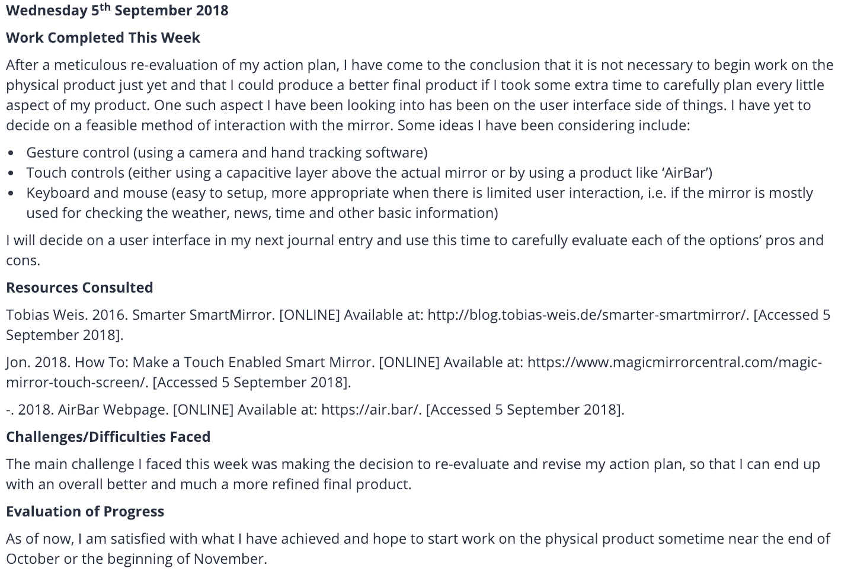

**Appendix B**

An extract from my process journal, about the new user-interface device:

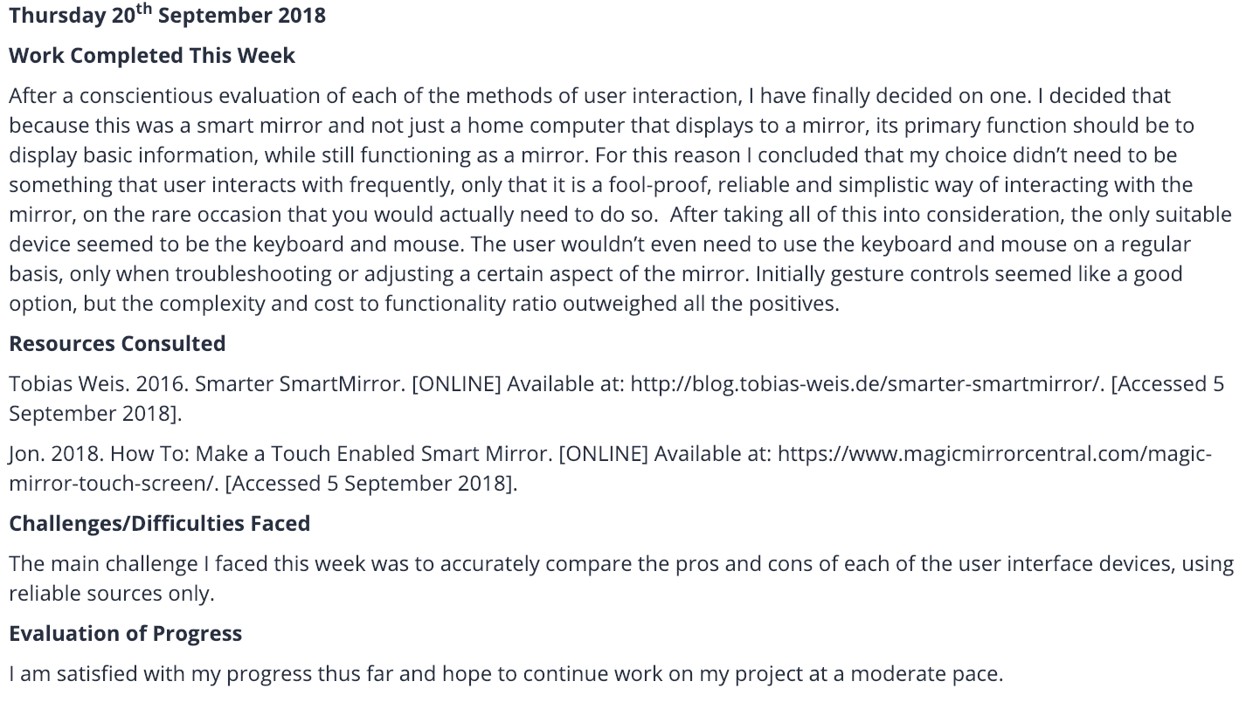

**Appendix C**

An image of the barebones software running on just the monitor (orientation had not been adjusted yet):

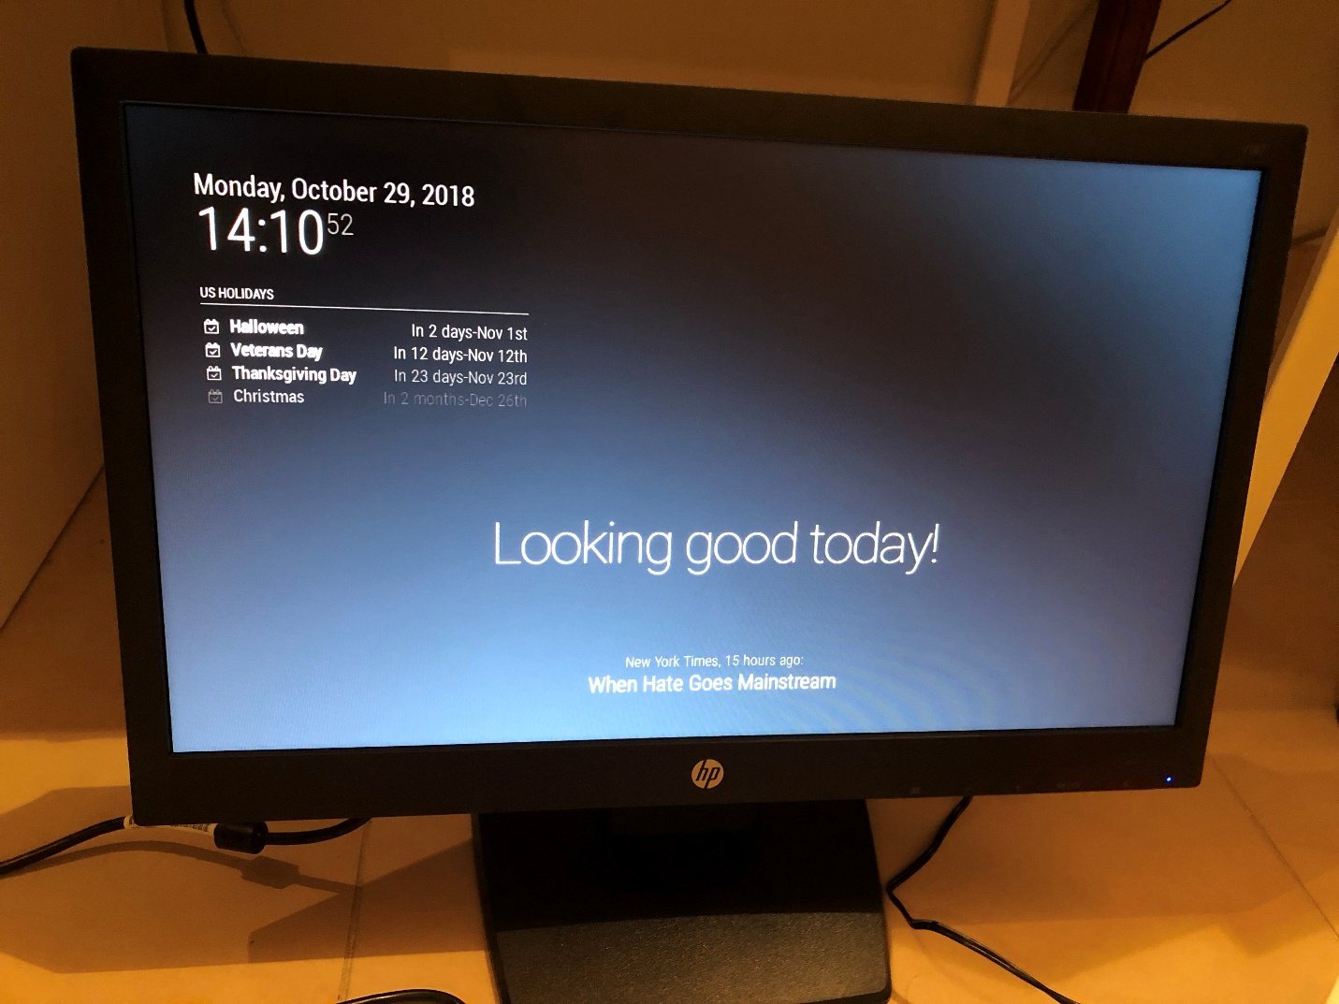

**Appendix D**

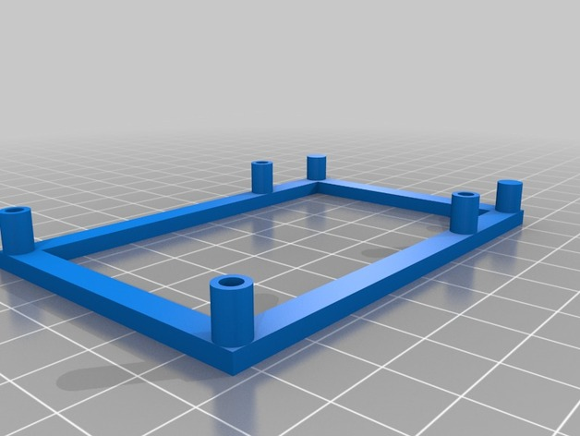A 3D model and a physical image of the 3D printed mount used to mount the Raspberry Pi to the back of the display:

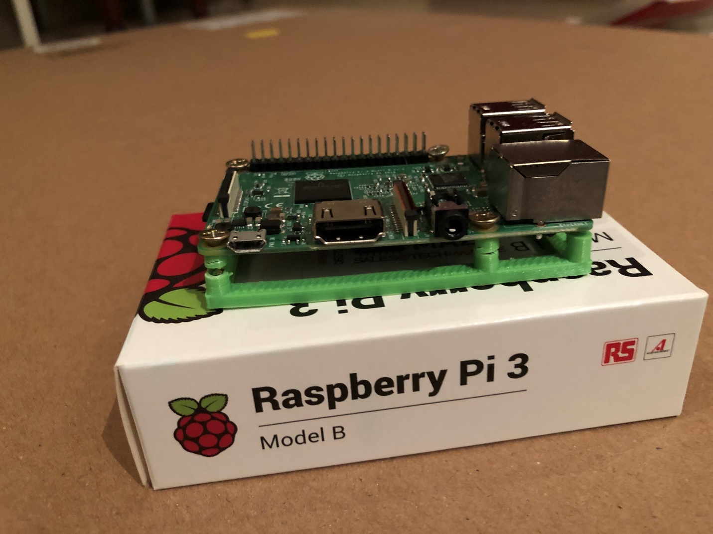

**Appendix E**

An image depicting the compiling and installation process of the software:

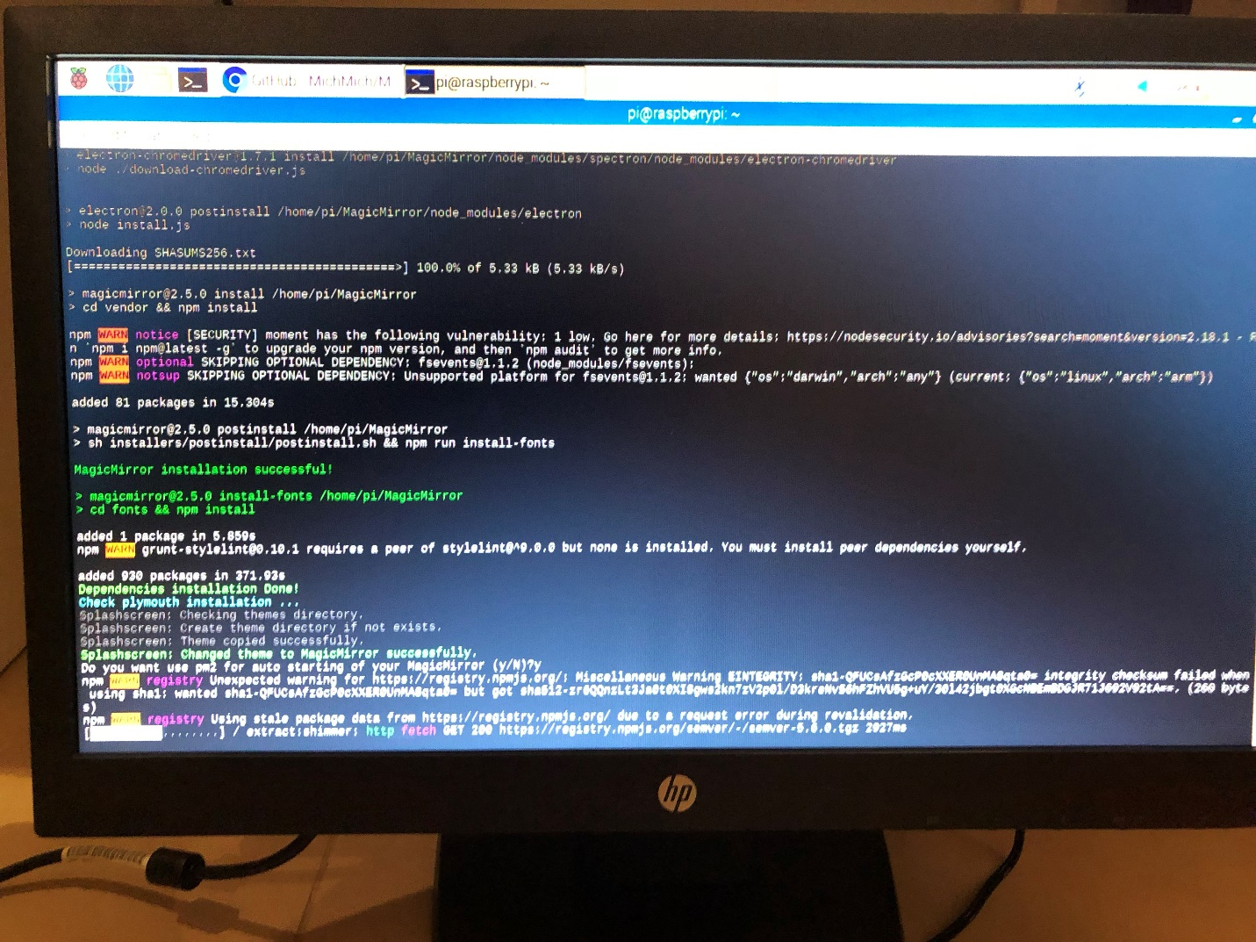

**Appendix F**

A screenshot of the marked student-designed rubric:

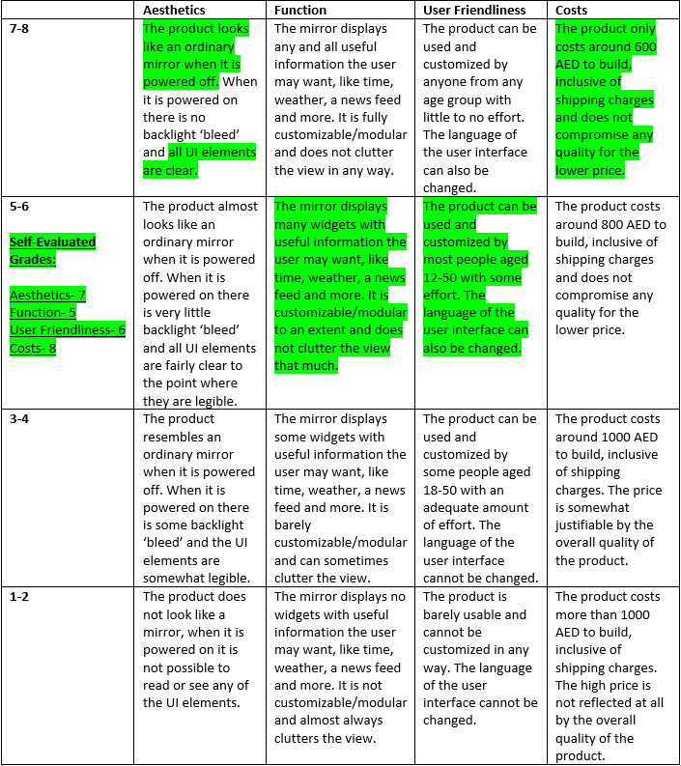

**Appendix G**

The results of a survey to see how many people would buy a smart mirror before and after trying it:

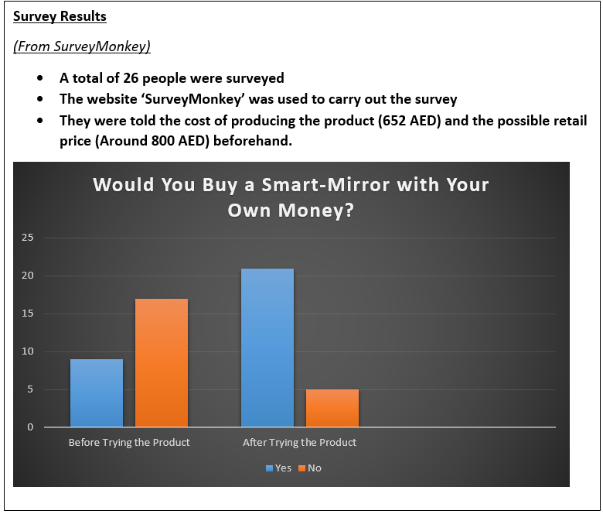

**Appendix H**

Two images depicting the wall mount used to mount the mirror to a wall before and after installation:

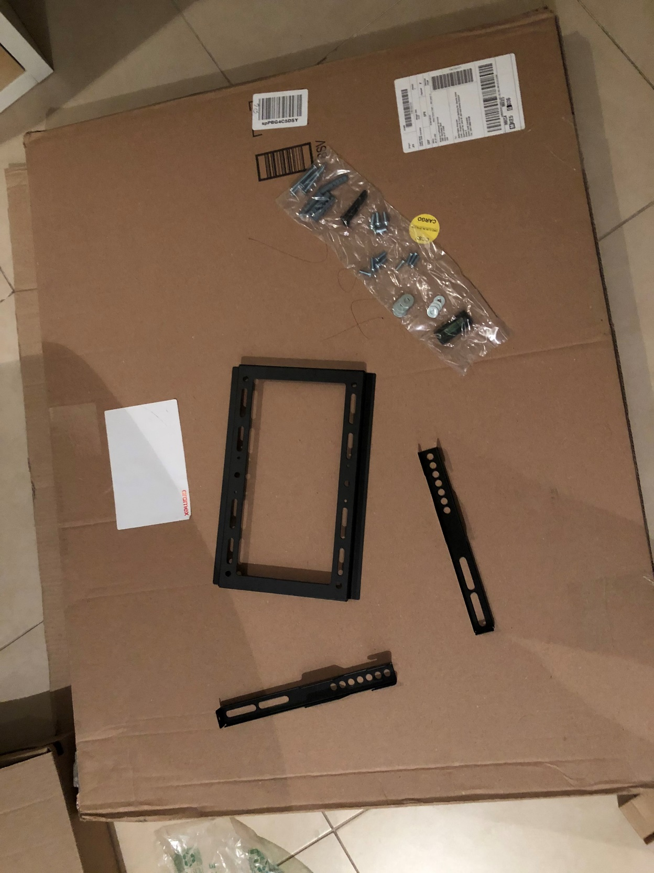

**Appendix I**

An image depicting the final product, not mounted on a wall (product is designed to be mounted on a wall and some widgets were unavailable during the time this photo was taken):

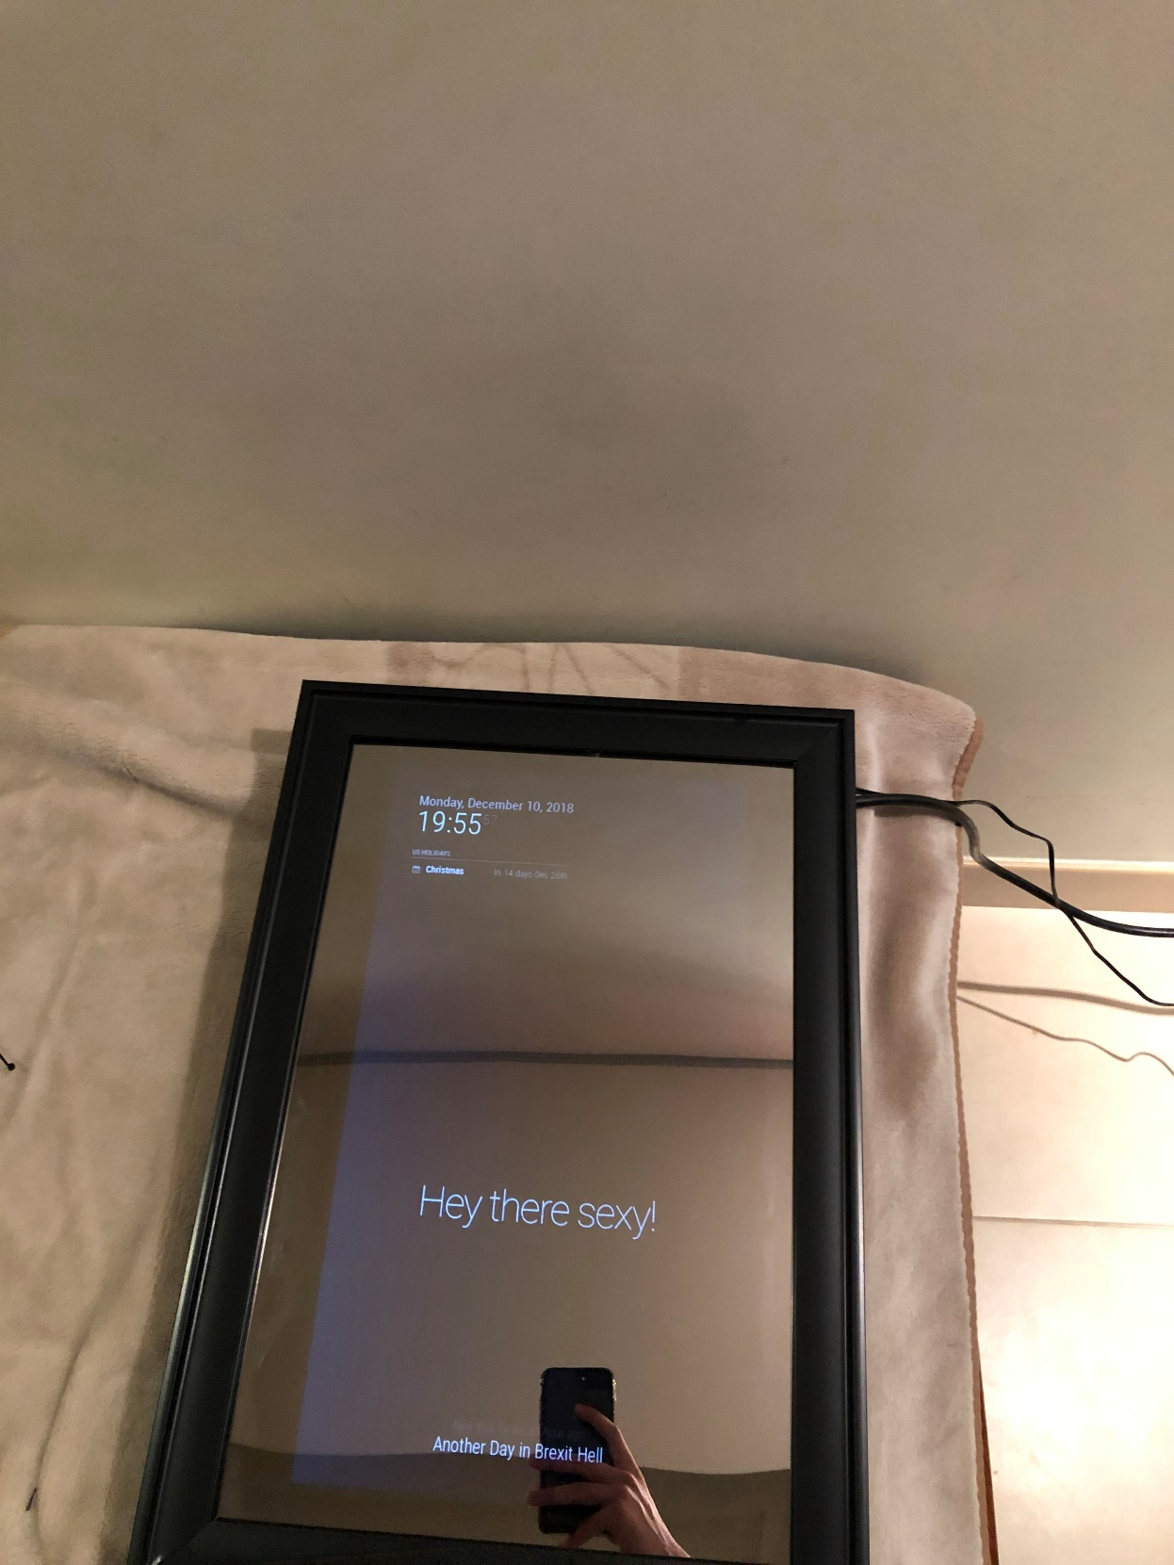

**Appendix J**

A screenshot of the ‘Criteria of Success’ table:

